History and Philosophy of Geography Research Group Engagement Award 2026

The History and Philosophy of Geography Research Group (HPGRG) of the Royal Geographical Society with the Institute of British Geographers (RGS-IBG) is launching a new initiative. Every two years, HPGRG will offer a small award of £150 to support projects which seek to widen audience engagement within the history and philosophy of geography.

Projects which meet our criteria might include public engagement through presentations, media presence, artwork, workshops, exhibitions, and other events, ideally in collaboration with museums, archives, savant societies and institutions, galleries and libraries, whose collections and purposes relate to themes about the histories and philosophies of geography. Examples include:

- public events or performances, installations, museum trails, and exhibitions;
- displays and content for actual or virtual spaces of public engagement, including posters, non-academic publications such as museum catalogues, and informal learning sheets;
- media articles, blog posts, social media posts, podcasts, video and audio files;
- specific events for school children or other diverse demographics.

This biannual award is open to doctoral students and early career postdoctoral researchers of geography and associated disciplines, both in academia and other sectors. Applications from around the world and from non-Anglophone countries are particularly encouraged but these would need to be submitted in the English language. Collaborative projects between geographers and practising artists, poets, musicians, actors, sculptors, or other performers will also be welcome. HPGRG also seeks to encourage applications from minority and underrepresented identity groups.

Recipients of this award will be offered the chance to showcase their work during the Annual General Meeting (AGM) of HPGRG (generally at the end of August or early September) and on the HPGRG website.

The scheme is designed to further the ambition of HPGRG to diversify participation in, and methods of presenting and practising, the history and philosophy of geography via works that communicate, integrate, and encourage geographical insights across diverse wider publics.

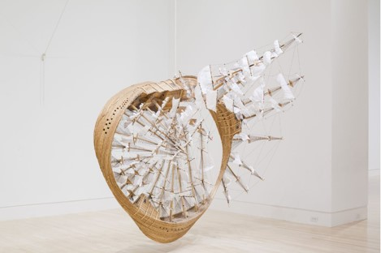
Any queries and/or completed application forms should be emailed to:
Dr Emily Hayes at ehayes@brookes.ac.uk by 30 June 2026.

History and Philosophy of Geography Research Group Engagement Awards

Application Form (text boxes can be expanded as necessary)
Name, contact details of applicant(s) and institutional affiliation

Title of conducted event/activity/project

Briefly describe your work/performance/event/activity/project (up to 500 words)

Please describe the audience for the event/activity/project in as much detail as possible. How is the work/performance/event/activity/project adapted to your designated audience? (up to 500 words)

Please describe the public engagement or educational aims of the project and
how they connect to, and inform, the histories and philosophies of geography
(up to 700 words)

Please describe the intended longer term and wider public engagement or educational outcomes of the project (up to 700 words)

Please number, title and date any attached images or files supporting this application. It is your responsibility to ensure that you have permission from any organising partners (museums, galleries or other hosting or facilitating institutions) to take and share these images, particularly if they depict children or vulnerable people. Proof of this may be requested from the HPGRG Committee.

How did you hear about the History and Philosophy of Geography Research Group Engagement Awards? (Please give as much detail as possible)

PRIVACY STATEMENT: The information provided will be treated in the strictest confidence. Relevant data, including name, contact details, project details and affiliation, will be processed under legitimate interest for the purposes of this public engagement award only. Names and affiliations of prize winners will be made public on our website and will be kept on record as part of the Society’s historical archive. More information on our privacy policy can be found on our website: https://hpgrg.org.uk.

